SCHOOL OF COMPUTER SCIENCE AND ARTIFICIAL INTELLIGENCE |  |  |  |  | DEPARTMENT OF COMPUTER SCIENCE ENGINEERING
ProgramName:B. Tech |  |  |  | Assignment Type: Lab |  |  | AcademicYear:2025-2026
CourseCoordinatorName |  |  |  | Venkataramana Veeramsetty
Instructor(s)Name |  |  |  | Dr. V. Venkataramana (Co-ordinator)  Dr. T. Sampath Kumar  Dr. Pramoda Patro  Dr. Brij Kishor Tiwari  Dr.J.Ravichander  Dr. Mohammand Ali Shaik  Dr. Anirodh Kumar  Mr. S.Naresh Kumar  Dr. RAJESH VELPULA  Mr. Kundhan Kumar  Ms. Ch.Rajitha  Mr. M Prakash  Mr. B.Raju  Intern 1 (Dharma teja)  Intern 2 (Sai Prasad)  Intern 3 (Sowmya)  NS_2 ( Mounika)
CourseCode |  |  | 24CS002PC215 | CourseTitle |  | AI Assisted Coding
Year/Sem |  |  | II/I | Regulation |  | R24
Date and Day  of Assignment |  |  | Week3 - Wednesday | Time(s)
Duration |  |  | 2 Hours | Applicableto  Batches
NAME : P SAI VENKAT ROLL NO : 2403A510G0 ASSIGNMENT 6.3
 | Q.No. | Question |  |  |  |  |  | ExpectedTime  to complete
 | 1 | Lab 6: AI-Based Code Completion – Classes, Loops, and Conditionals  Lab Objectives:  - To explore AI-powered auto-completion features for core Python constructs.  - To analyze how AI suggests logic for class definitions, loops, and conditionals.  - To evaluate the completeness and correctness of code generated by AI assistants.  Lab Outcomes (LOs):  After completing this lab, students will be able to:  - Use AI tools to generate and complete class definitions and methods.  - Understand and assess AI-suggested loops for iterative tasks.  - Generate conditional statements through prompt-driven suggestions.  - Critically evaluate AI-assisted code for correctness and clarity.  Task Description#1 (Classes)  - Use AI to complete a Student class with attributes and a method.  - Check output  - Analyze the code generated by AI tool  PROMPT:  Use AI to complete a Student class with attributes and a method.  • Check output  • Analyze the code generated by AI tool  CODE:  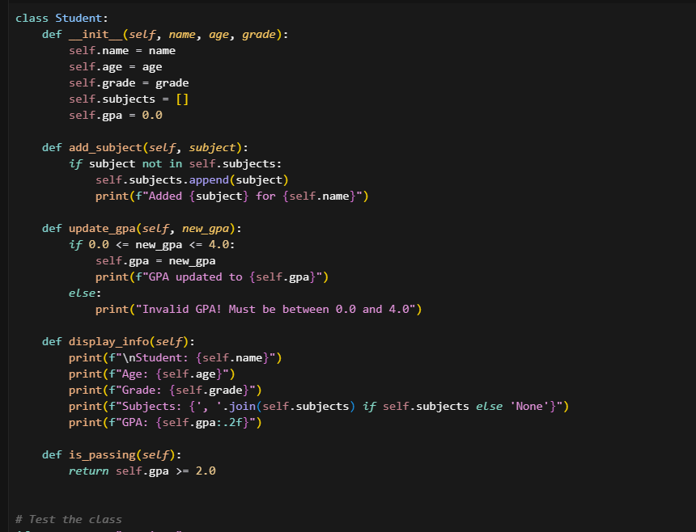  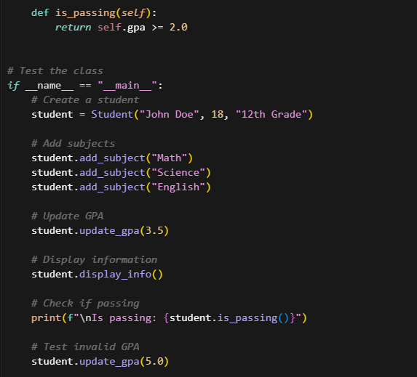  Expected Output#1  - Class with constructor and display_details() method  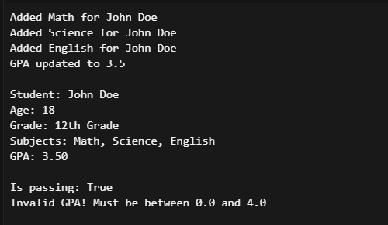  Task Description#2 (Loops)  - Prompt AI to complete a function that prints the first 10 multiples of a number using a loop.  - Analyze the generated code  - Ask AI to generate code using other controlled looping  PROMPT:  Use AI to complete a Student class with attributes and a method.  • Check output  • Analyze the code generated by AI tool  CODE:  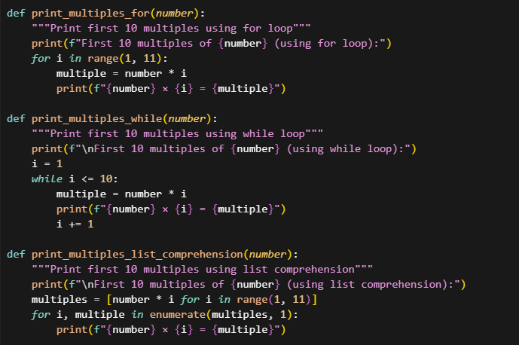  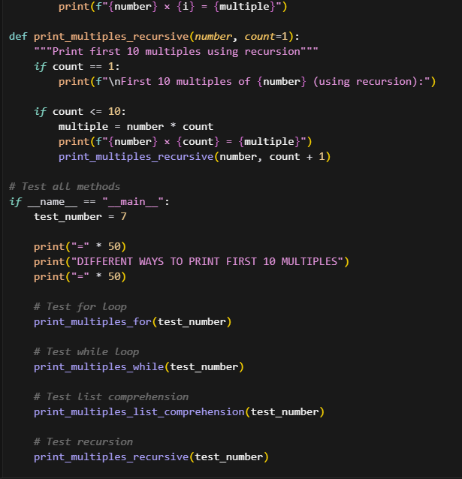  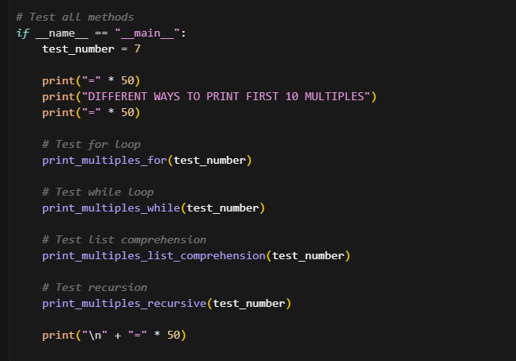  Expected Output#2  - Correct loop-based implementation  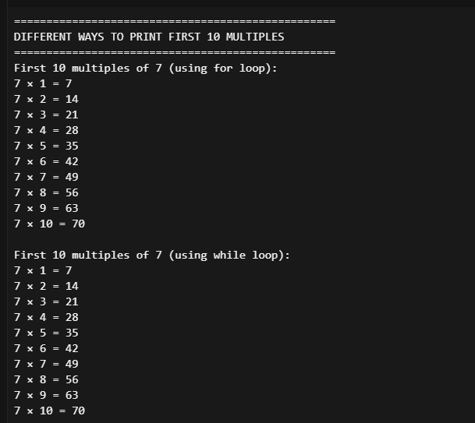  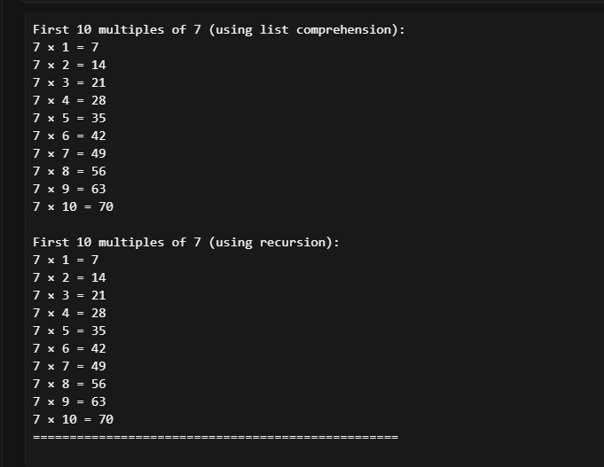  Task Description#3 (Conditional Statements)  - Ask AI to write nested if-elif-else conditionals to classify age groups.  - Analyze the generated code  - Ask AI to generate code using other conditional statements  PROMT:  Write a Python program using nested if-elif-else statements to classify people into age groups (child, teenager, adult, senior). Then analyze the code and explain how it works. After that, rewrite the program using a different type of conditional structure (like separate if conditions or match-case).  CODE:  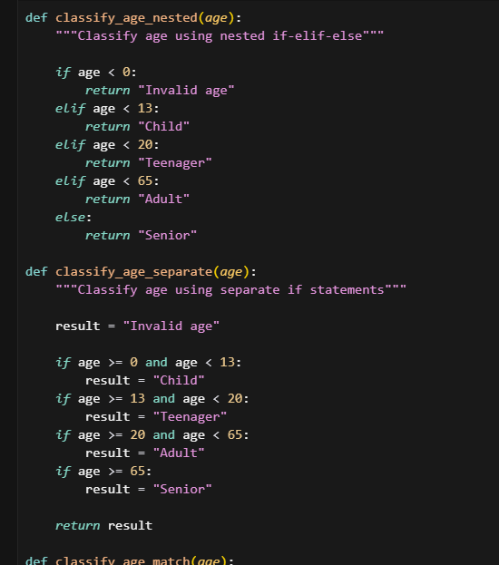  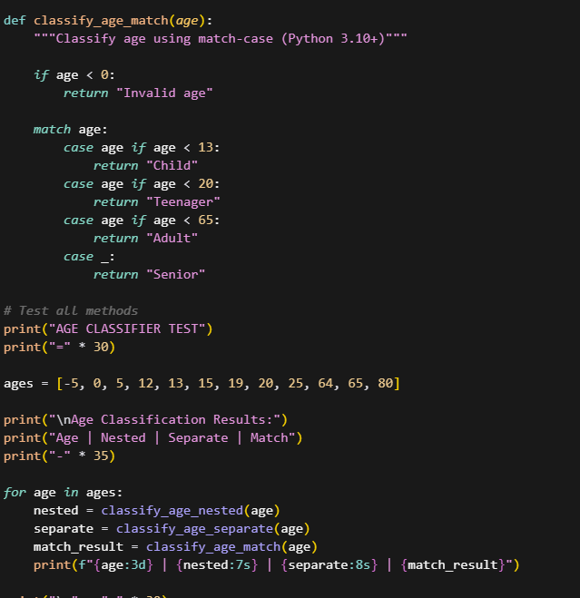  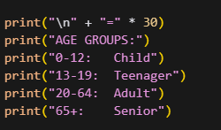  Expected Output#3  - Age classification function with appropriate conditions and with explanation  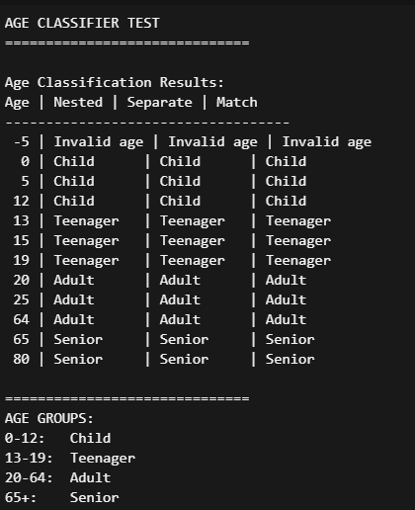  EXPLANATION:  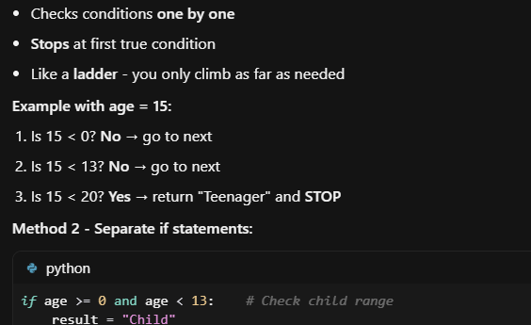  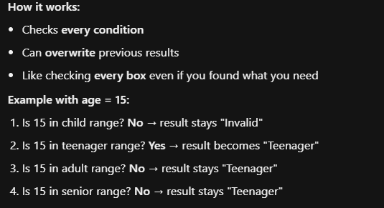  Task Description#4 (For and While loops)  - Generate a sum_to_n() function to calculate sum of first n numbers  - Analyze the generated code  - Get suggestions from AI with other controlled looping  PROOMT:  Write a Python function sum_to_n(n) that calculates the sum of the first n natural numbers using a loop. Explain how the code works. Then, suggest and show other ways to do it using different loops (like while loop, for loop, etc.).  CODE:  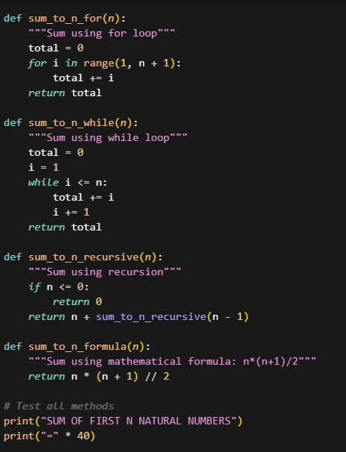  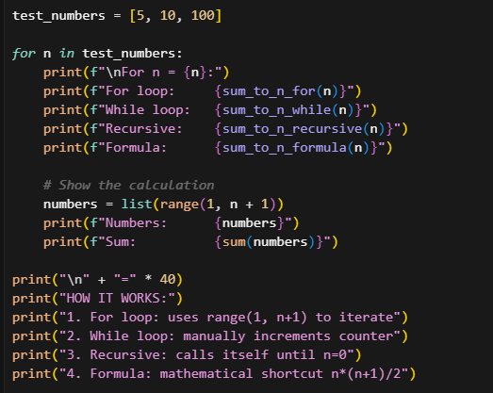  Expected Output#4  - Python code with explanation  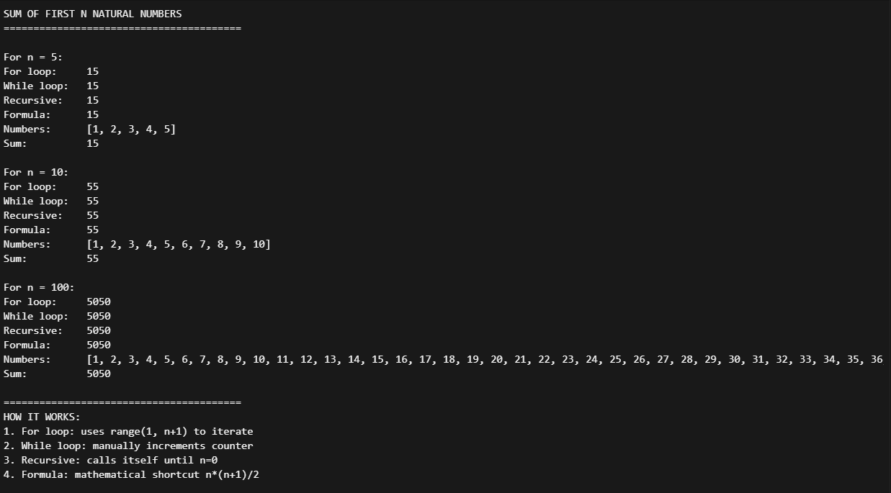  EXPLANATION:  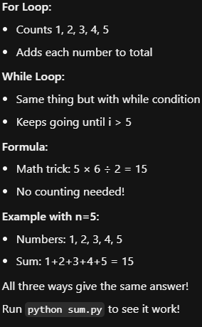  Task Description#5 (Class)  - Use AI to build a BankAccount class with deposit, withdraw, and balance methods.  - Analyze the generated code  - Add comments and explain code  PROMT:  Write a Python class BankAccount with methods to deposit money, withdraw money, and check balance. Explain how the code works. Then add comments in the code to make it easy to understand.  CODE:  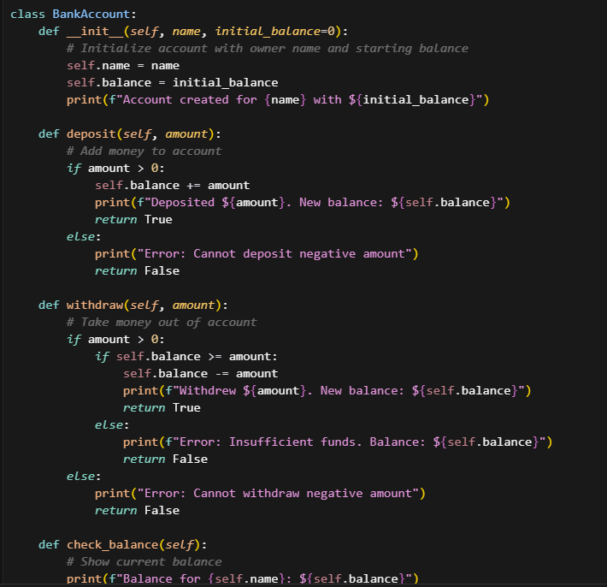  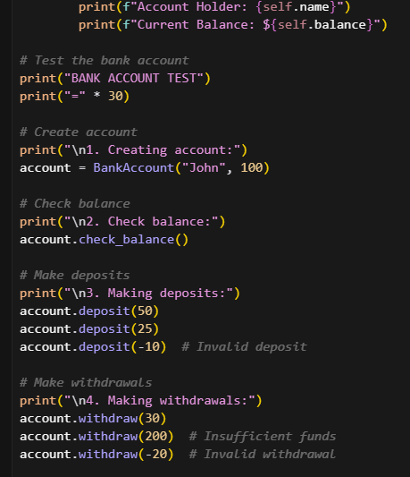  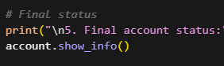  Expected Output#5  - Python code with explanation  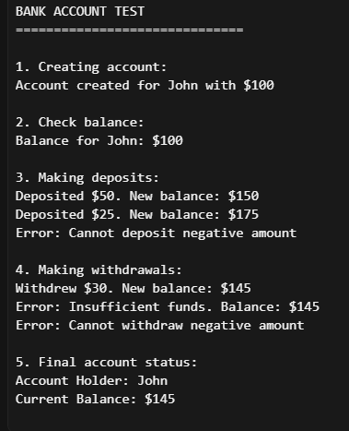  Note: Report should be submitted a word document for all tasks in a single document with prompts, comments & code explanation, and output and if required, screenshots  Evaluation Criteria:  Criteria Max Marks  Class 1.0  Loops 1.0  Conditional Statements 0.5  Total 2.5 Marks |  |  |  |  |  | Week3 - Wednesday

